# The Game Development minor

The United States and global games industry continues to be one of the most diverse and healthy available for job-seekers. In the United States alone, the games industry employs more than 32,000 people across 34 states, reaching a total compensation of over three billion dollars annually.   
   
As one of a growing number of interdisciplinary programs at Penn State Behrend, students can now opt to enroll in a minor in Game Development.  
   
The Game Development minor is designed to augment any degree at Behrend, and fits nicely into a four-year schedule, augmenting student learning and marketability, and aiding in the completion of general education credits.   
   
The minor consists of 18 total credits:

* 9 credits of Breadth courses (100 and 200 level)
* 6 credits of Depth courses (400 level)
* 3 credits in a Senior Project course (GAME 480)

Students can take these courses in any year of enrollment, but they are designed to be taken in ascending order, as many courses require a prerequisite.   
  
Topics in Game Development available at Penn State Behrend cover topics reaching from Programming and Artificial Intelligence, to Design and Mechanics.

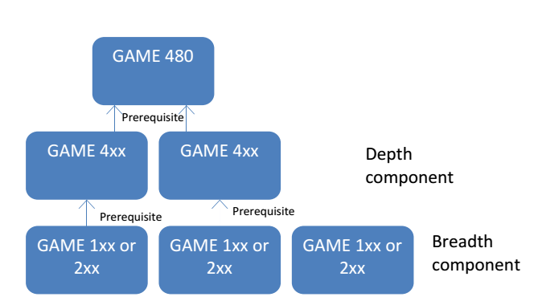

**Courses Offered:**

**PSU 007**: First-Year Seminar (Game-Focused)  
**GAME 140**: Gaming and Interactive Media (GS)  
**GAME 160**: Introduction to Video Game Culture (GH; US; IL) (also as CMLIT191)  
**GAME 220**: Introduction to Game Design (GA)  
**PSYCH 244**: Psychology of Human Factors Engineering (GS) (counts as GAME2xx)  
**GAME 250**: Technical Game Development (GQ)  
**GAME 251**: 2D Web Game Development (GQ)  
**GAME 420**: Advanced Game Design  
**GAME 434**: Psychology of Gaming (also as PSYCH434)  
**GAME 450**: Advanced Game Programming  
**GAME 460**: Video Game Literature Studies (also as CMLIT490)  
**GAME 480**: Game Development Senior Project  
**GAME 495**: Senior Internship